SRE 1330 TC-2 HEATER
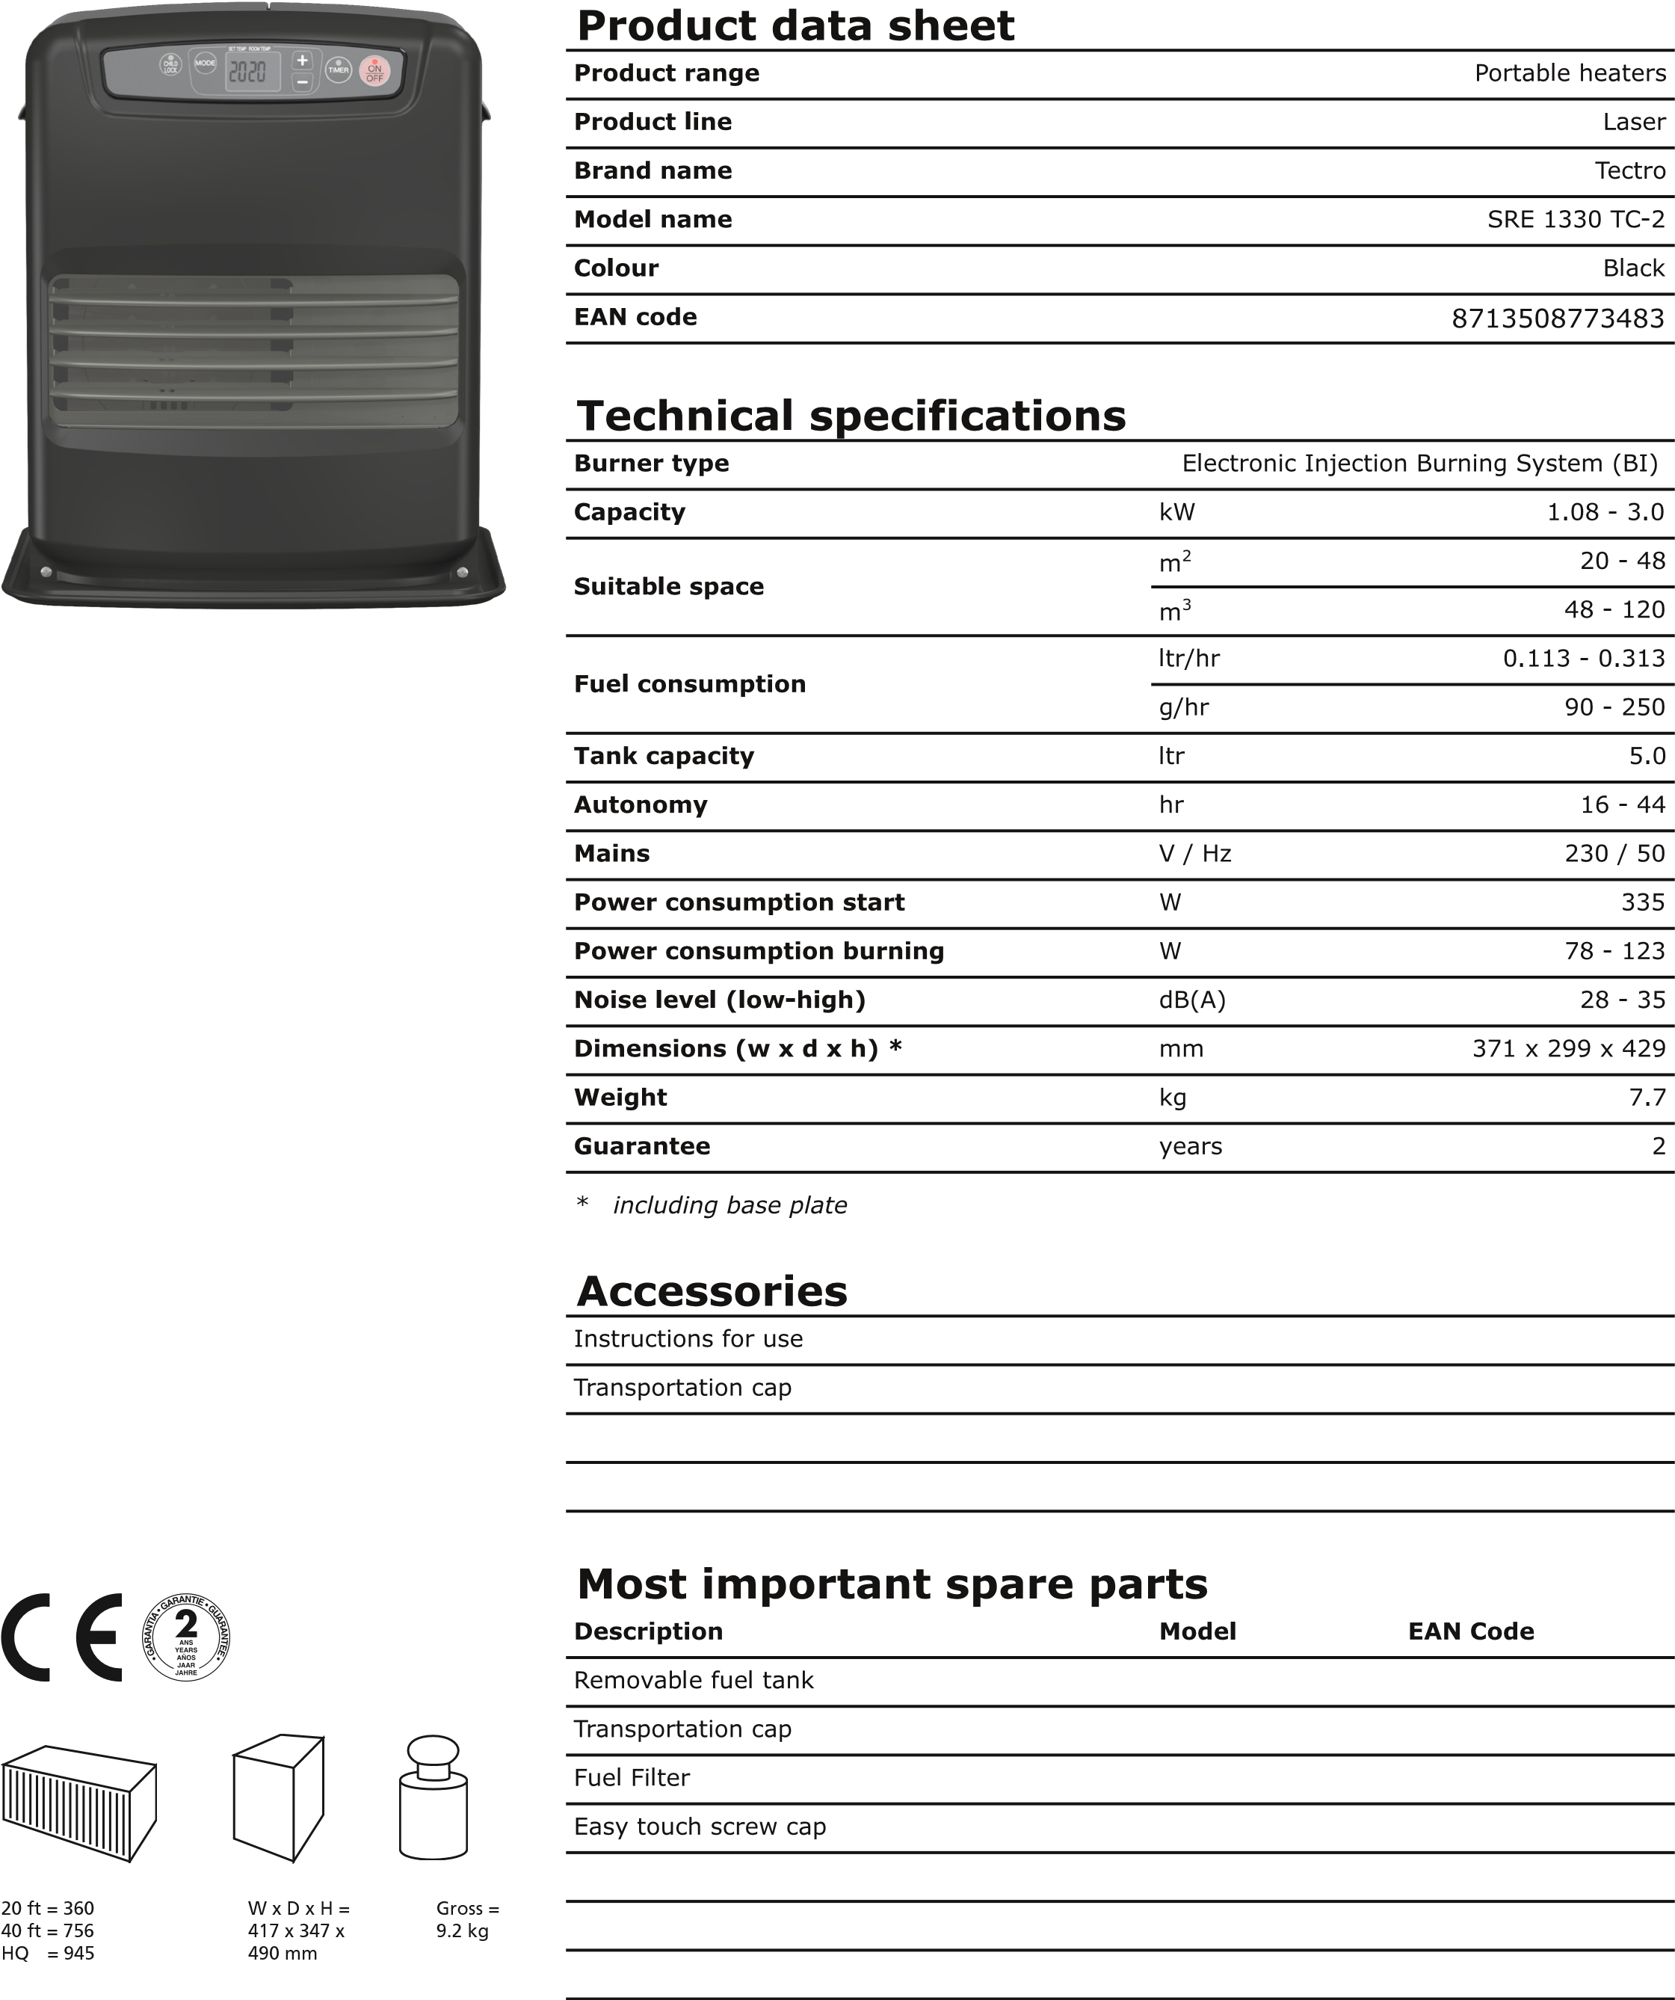
SRE 1330 TC-2 HEATER
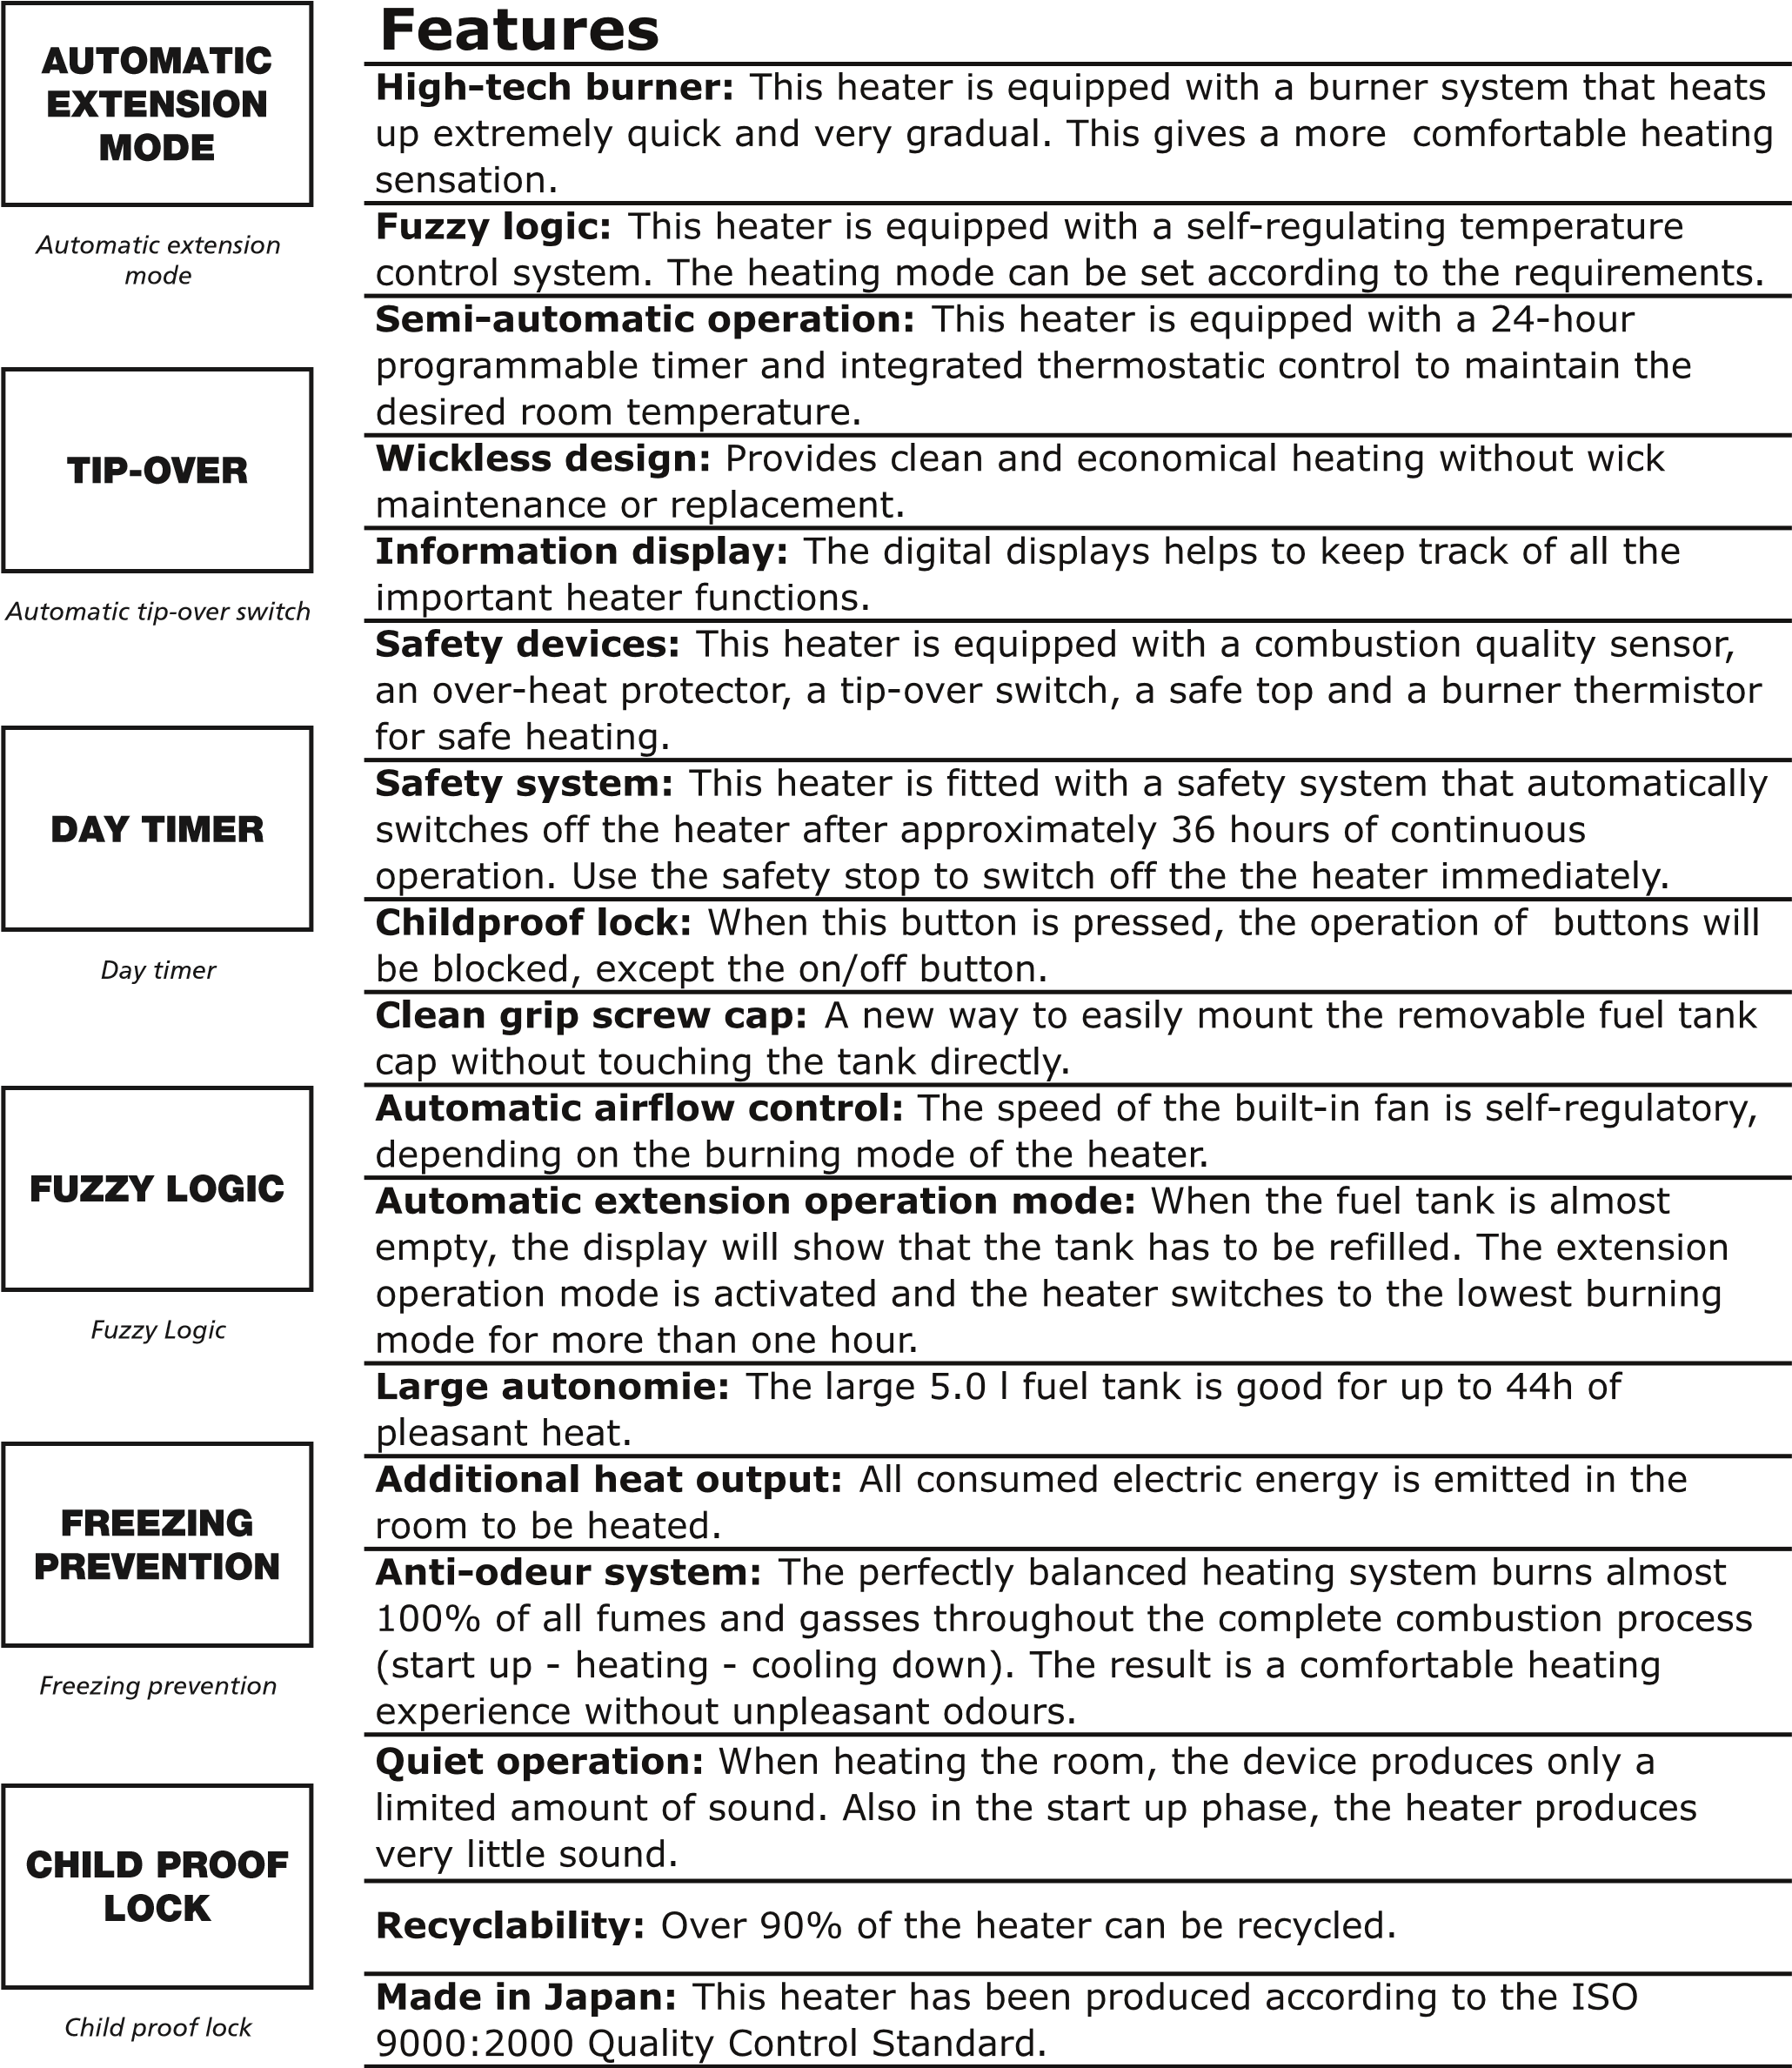
ROOM  TEMPERATURE  THERMISTOR |  | SAFETY STOP |  | MADE IN JAPAN
Room temperature Safety stop Made in Japan thermistor

